PROJECT DOCUMENTATION
FINAL REPORT


TOPIC:
6x6 PlayFair Cipher

Submitted By:
M. Abu Hurairah Nazar BITF24A037
Submitted to:
Mr. Huzaifa Nazir

Briefing Document: Extended 6x6 Playfair Cryptographic System

Introduction
The Extended 6x6 Playfair Cryptographic System is a C++ security application providing robust alphanumeric encryption. By expanding the traditional 5x5 matrix to a 36-character grid (A-Z, 0-9), the system eliminates character merging (like 'I'/'J') and ensures full data integrity for modern files containing numeric data.
Key Technical Features
- Enhanced Matrix: A 6x6 grid supporting all 26 letters and 10 digits without character loss.
- "Double-Lock" Security: Implements a multi-layered key management protocol where a Master Password is required to unlock the keyword that generates the cipher matrix.
- Robust Processing: Utilizes digraph-based substitution and format-preserving file I/O to maintain original file structures.
- Professional UI: Features a streamlined terminal-based interface designed for efficiency and ease of use.

--------------------------------------------------------------------------------------------------------------------------------
Problem Statement
Introductory cryptographic projects often suffer from two primary weaknesses: character limitation and insecure key storage. This project addresses these by:
- Eliminating Data Loss: Standard 5x5 matrices cannot handle numbers, which often remain unencrypted or are deleted entirely. The 6x6 implementation provides full alphanumeric support.
- Securing the Key Vault: Storing encryption keys in plain text is a significant vulnerability. This system implements "Key Wrapping," where the primary keyword is encrypted via a Master Password using XOR logic before being stored in an external secret key file.
- Balancing Complexity and Security: While simpler ciphers like Caesar or Vigenère are vulnerable to brute-force or basic frequency analysis, the Playfair cipher's use of digraphs (pairs of letters) flattens frequency distribution, making it significantly more resistant to manual cryptanalysis.

--------------------------------------------------------------------------------------------------------------------------------
Technical Architecture and Encryption Logic
The system is built using Object-Oriented Programming (OOP) in C++, encapsulating all logic within a PlayfairCipher class.
1. The 6x6 Cipher Matrix
The "Engine" of the system is a 2D array (char matrix[6][6]).
- Matrix Generation: The matrix is populated first by a cleaned version of the user's keyword (removing duplicates) and then filled with the remaining characters of the alphabet and numbers 0-9.
- Alphanumeric Support: By including digits, the system avoids the "I/J" merging problem, ensuring that every character in the matrix is unique and identifiable.
2. Digraph Substitution Rules
Playfair encryption operates on pairs of characters. The system identifies the coordinates of each pair in the matrix and applies one of three geometric rules:
Rule | Scenario | Encryption Action (Right/Down) | Decryption Action (Left/Up)
Rectangle | Different rows and columns | Swap column indices; stay in own row. | Swap column indices; stay in own row.
Same Row | Characters are in the same row | Shift both right: (col + 1) % 6 | Shift both left: (col + 5) % 6
Same Column | Characters are in the same column | Shift both down: (row + 1) % 6 | Shift both up: (row + 5) % 6

3. Text Processing and Padding
To ensure the digraph logic never fails, the system applies specific "cleaning" rules:
- Double-Letter Rule: If a pair contains the same letter (e.g., "EE"), an 'X' is inserted (e.g., "EX", "EX").
- Odd-Ending Rule: If the final message length is odd, an 'X' is appended to complete the final pair.
- Infinite-Iteration: If a word has letters “XX” in it, an ‘Q’ is inserted instead of an ‘X’ to avoid logic errors while decryption (e.g. “XX” becomes “XQ”, “XQ”)
- Format Preservation: During file I/O, the system uses a "pass-through" strategy. Spaces, newlines, and special symbols are written directly to the output file in their original positions, ensuring the document's structure remains intact after decryption.
--------------------------------------------------------------------------------------------------------------------------------
Security Mechanisms
The project implements a three-layered security approach:
- Layer 1: The Master Password (Something you know): A user-defined code that XOR-encrypts the keyword.
- Layer 2: The Key File (Something you have): An external secret.key file containing the "wrapped" (encrypted) keyword.
- Layer 3: The 6x6 Scrambler: The algorithmic logic that performs the digraph substitution on the actual data.
--------------------------------------------------------------------------------------------------------------------------------
User Interface and Functionality
The application is presented as a professional Command Line Interface (CLI) using ANSI color codes characters to simulate a "Security Terminal."
Key Features of the Interface:
- File Analysis: A built-in tool to analyze text statistics (alphanumeric count, uppercase/lowercase distribution) for both original and encrypted files.
- Bulk Processing: Functions for encryptFile and decryptFile that handle large documents while preserving formatting.
- Input Validation: Robust error-handling for menu selections and keyword inputs to prevent program crashes.

--------------------------------------------------------------------------------------------------------------------------------
Proof Of Implementation
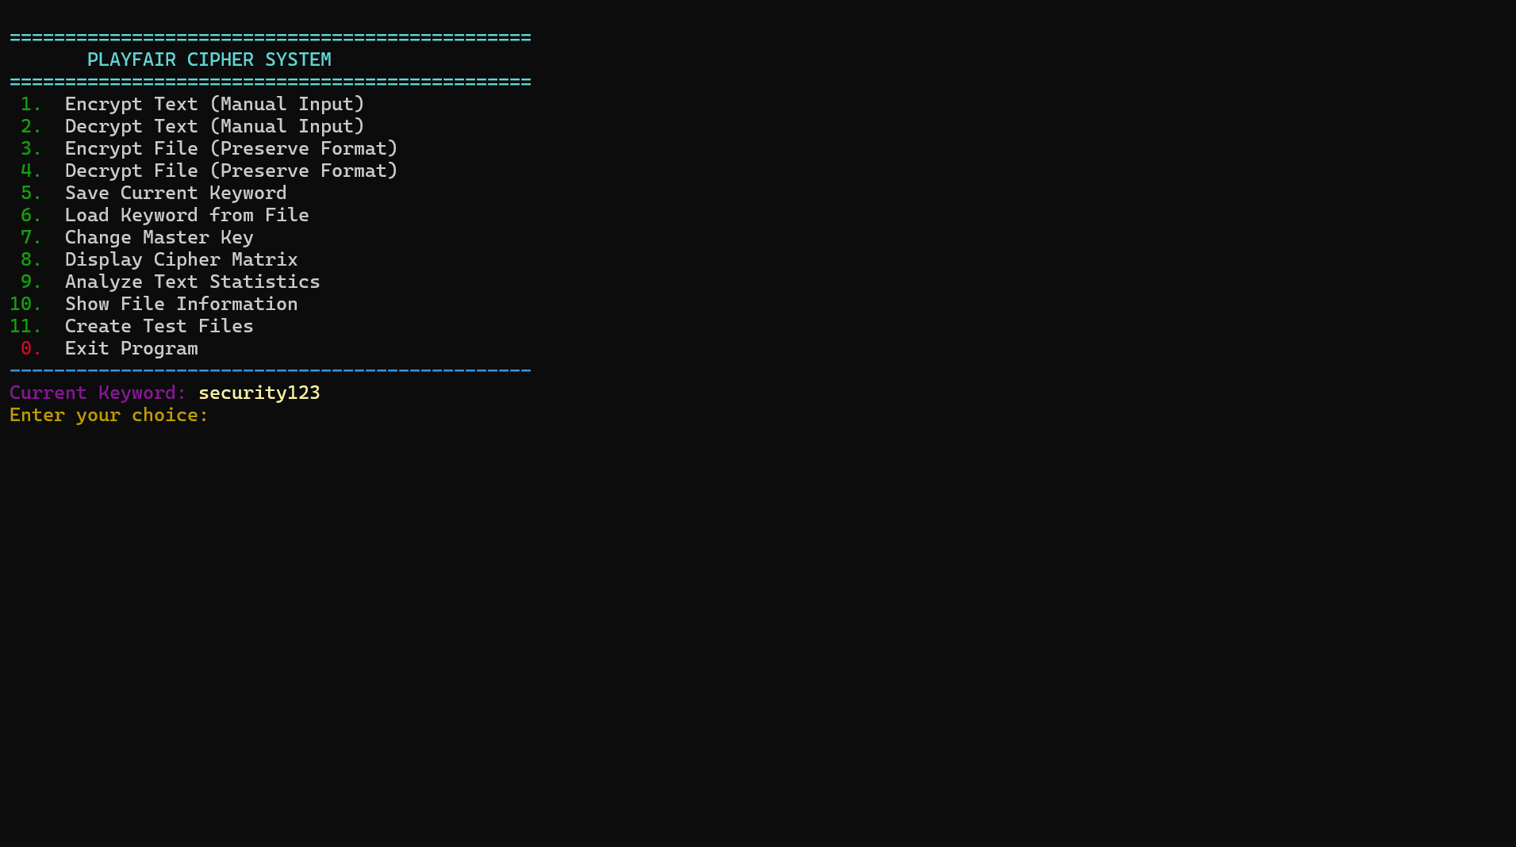

- Manually writing text to encrypt
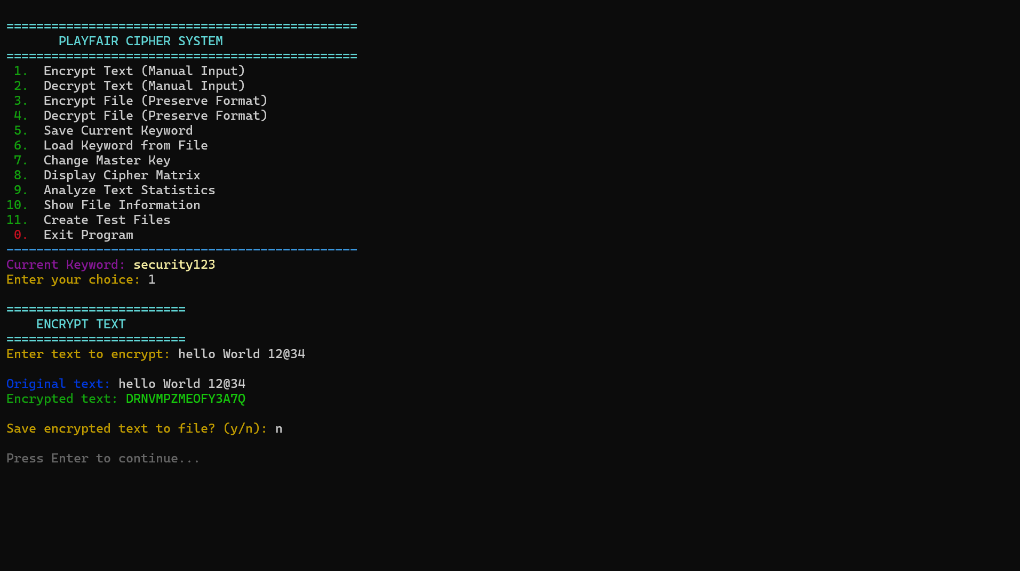

- Encrypting a file “message.txt” with preserved Format

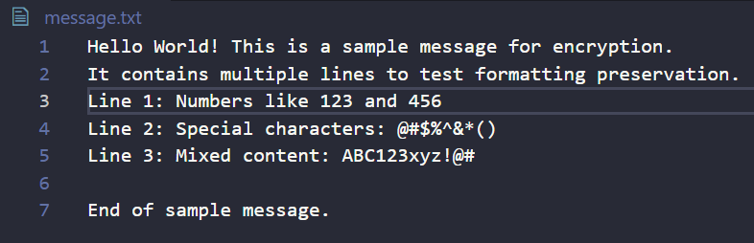
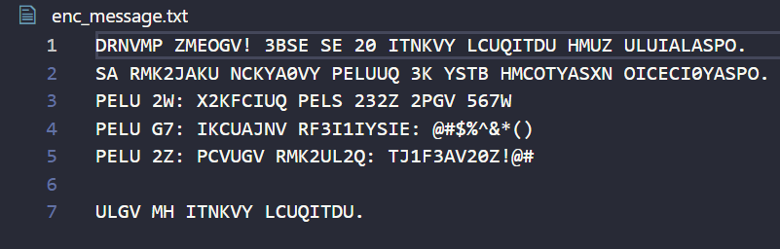
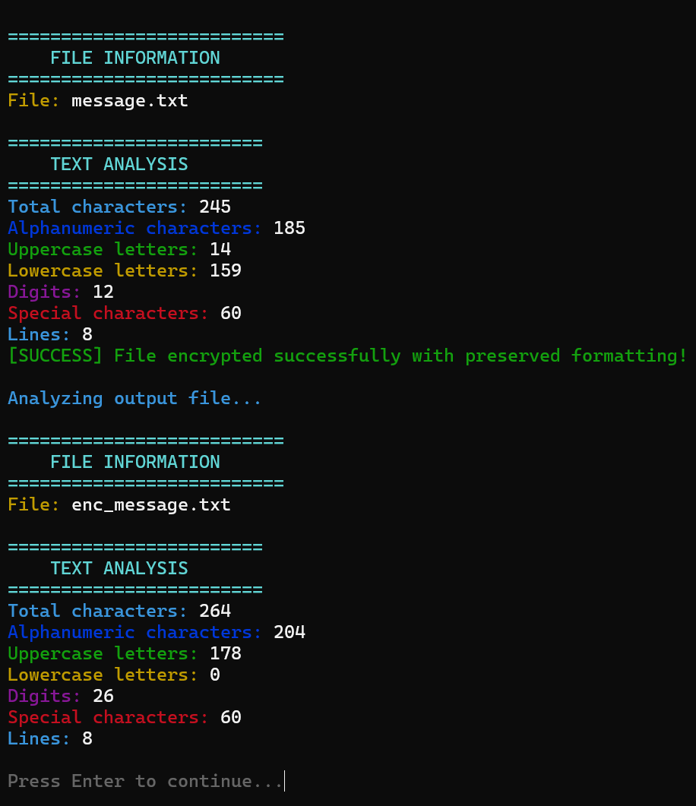

- Decrypting an encrypted File with preserved Formatting
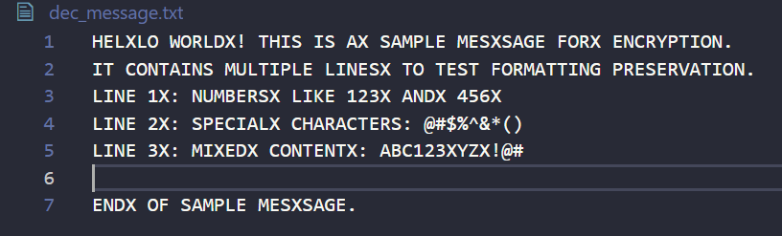

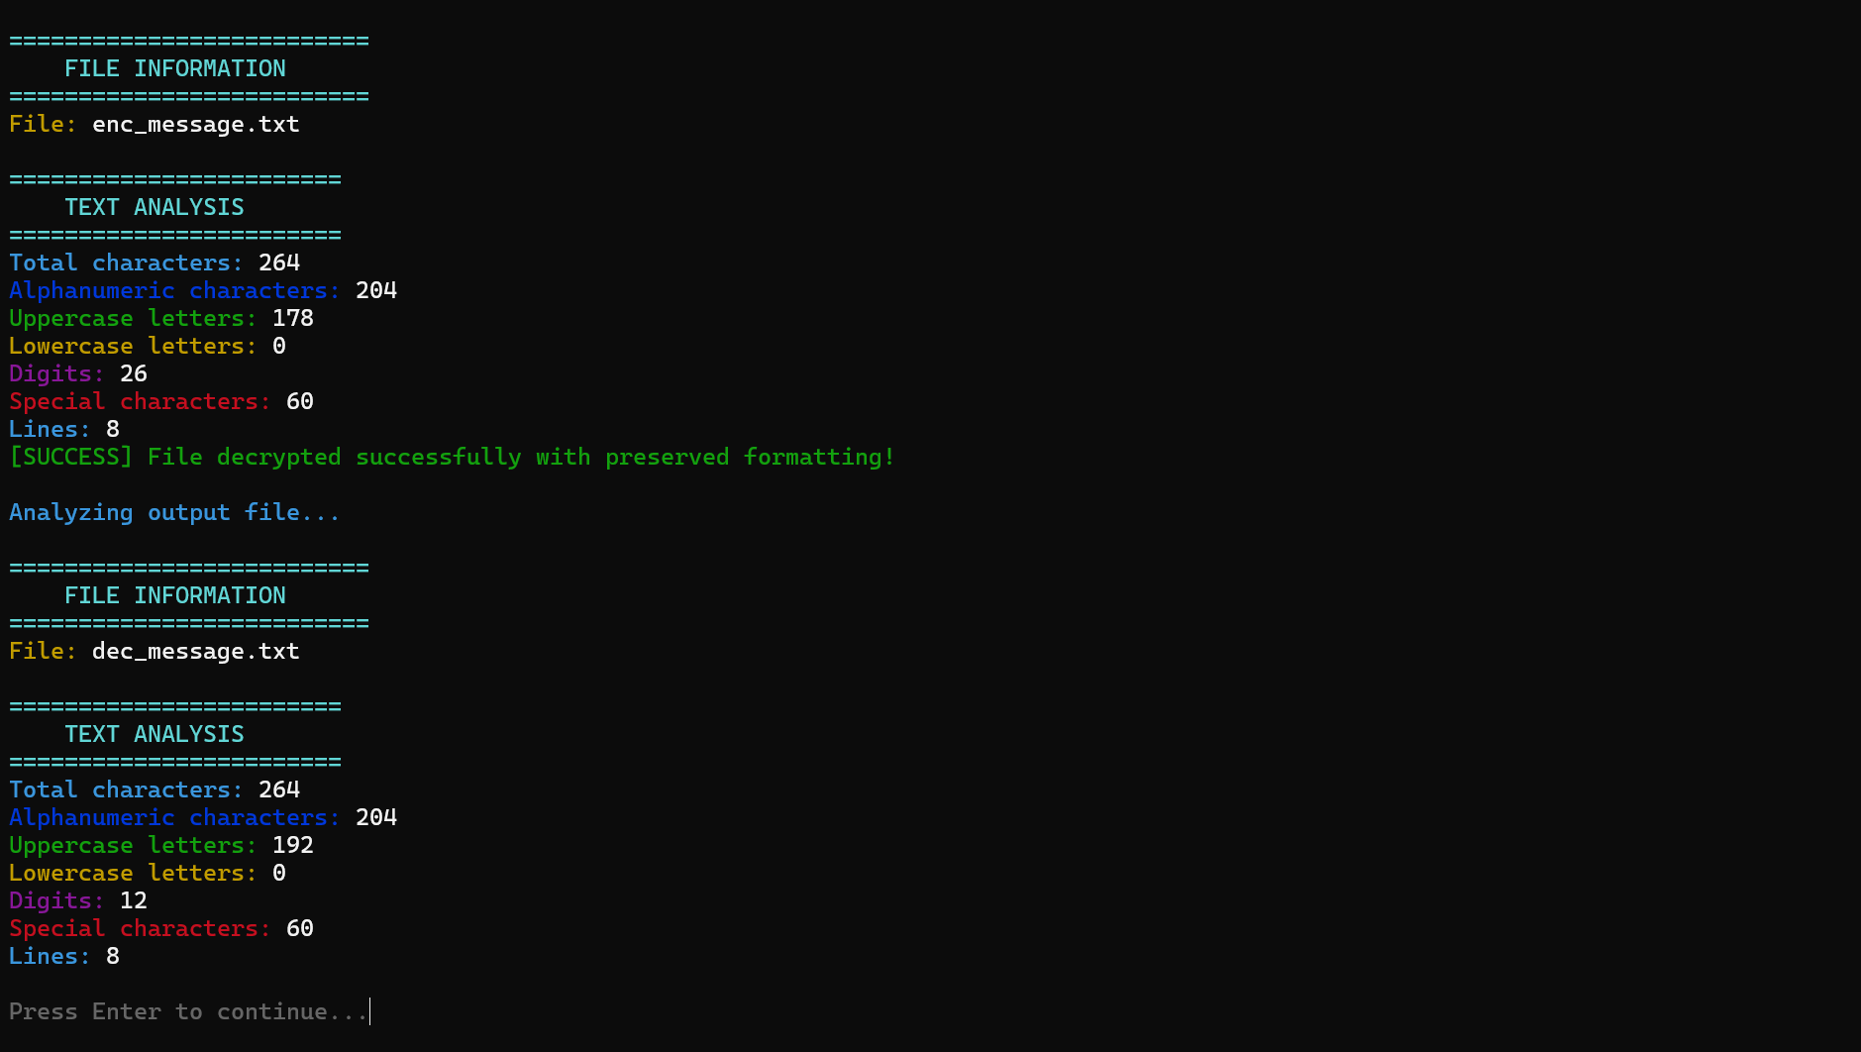

- Displaying Cipher
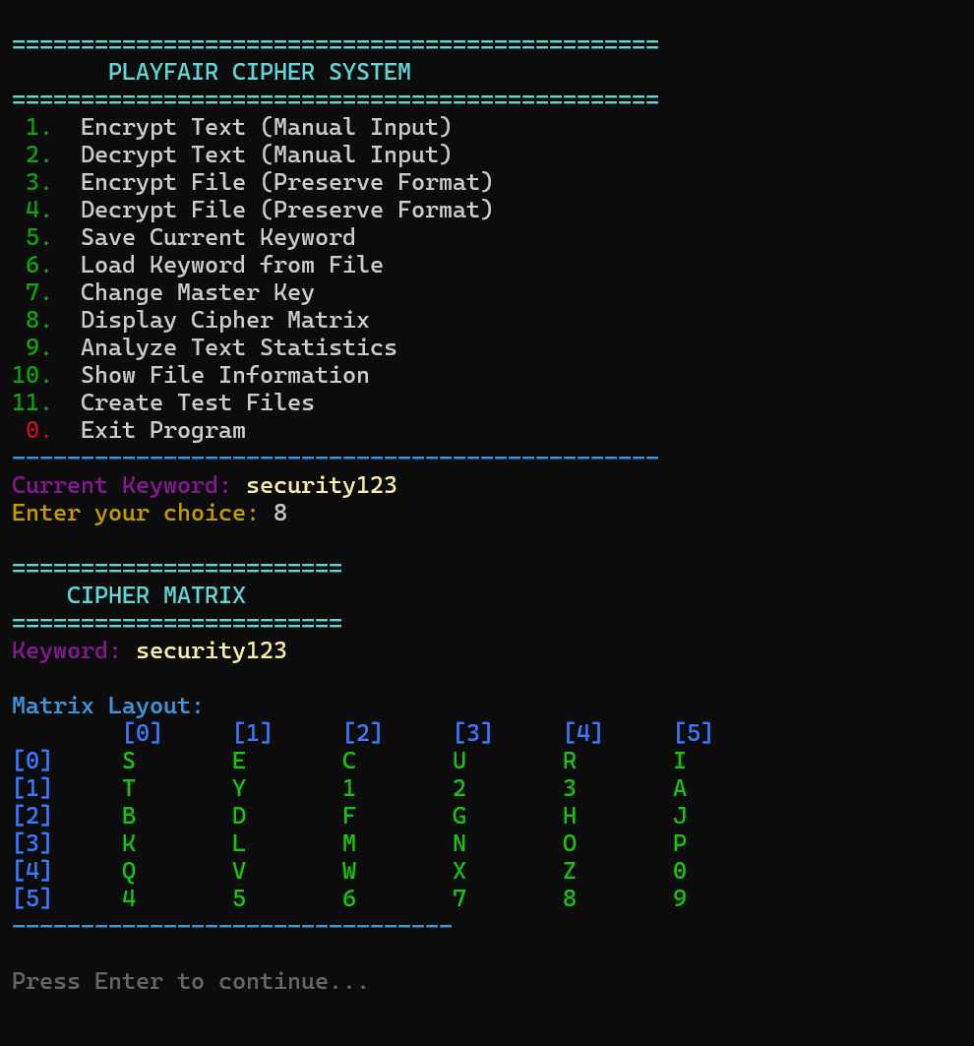

- File Analysis
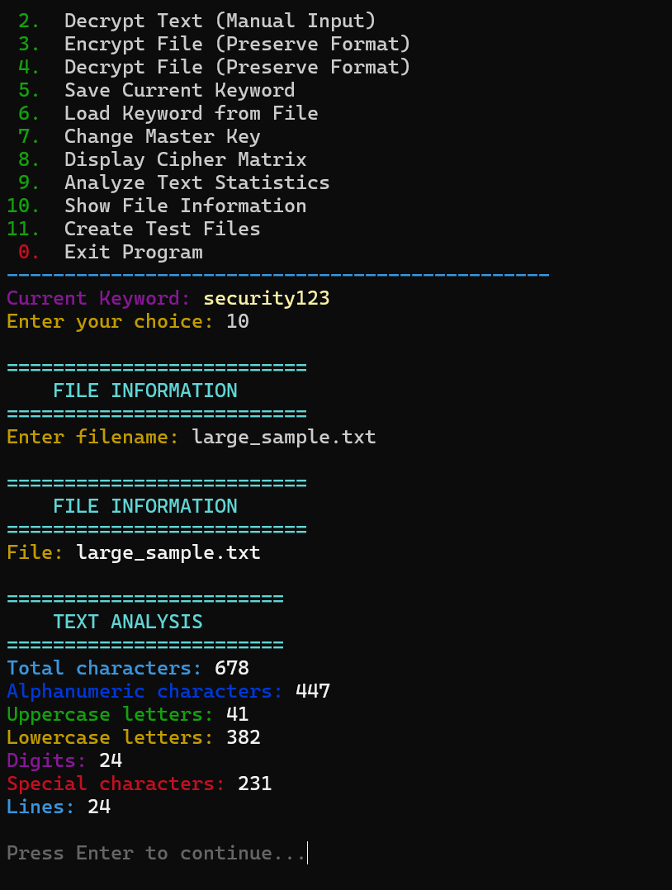
--------------------------------------------------------------------------------------------------------------------------------
Scope, Limitations, and Future Roadmap
Current Scope and Limitations
- In-Scope: Full alphanumeric encryption, key wrapping, format preservation, and class-based C++ architecture.
- Case Sensitivity: The current matrix converts all input to uppercase, meaning case information is lost during the transformation.
- Special Character Exposure: While symbols like @ or # are preserved, they are not encrypted, which could potentially reveal patterns to an attacker.
Future Roadmap
- 8x8 Matrix Expansion: Upgrading the grid to include all 256 ASCII characters, allowing for the encryption of binary files (images/PDFs) and all special symbols.
- Salted Key Hashing: Replacing XOR logic with SHA-256 hashing combined with a "salt" to secure the secret.key file against brute-force attacks.
- Integrity Checksums: Implementing HMAC (Hash-based Message Authentication Code) to detect if an encrypted file has been tampered with by an unauthorized party.

